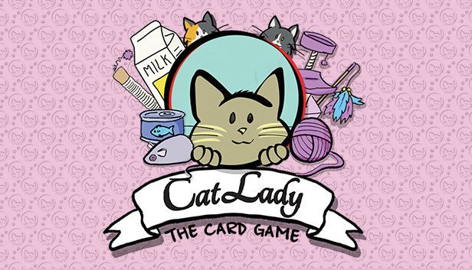
Game Title: Cat Lady: The Card Game
Developer: Nomad Games
Publisher: Nomad Games
Platforms: Windows PC, iOS and Android
Genre: Board Game
Release Date: February 19th 2020 (Steam), November 9th 2018 (iOS and Android)
The purr-fect board game adaptation is here!
Based on the much-loved card-drafting game from Josh Wood, Cat Lady: The Card Game is the digital adaptation of Cat Lady from AEG. Developed by Nomad Games, the studio behind such hits as Talisman: Digital Edition, Mystic Vale and Fury of Dracula: Digital Edition, Cat Lady: The Card Game is another digital board game adaptation for players to enjoy.
In Cat Lady: The Card Game, players are tasked with creating the very best cattery they can as they compete against other Cat Ladies. By carefully selecting and drafting different cats, toys, costumes and food, players aim to score the most points. At the end of each game, players must then make sure to feed their cats properly using the food they’ve gathered and get as many points as they can.
Featuring a range of AI difficulties for players to pit themselves against and tons of achievements to unlock, Cat Lady: The Card Game offers something for fans of the physical game and people who’ve never experienced the joy of accepting their inner Cat Lady.
Cat Lady: The Card Game is available on Windows PC via Steam, Google Play and the App Store.
Social Links
Web: https://www.nomadgames.co.uk/
Twitch: https://www.twitch.tv/nomad_games
YouTube: https://www.youtube.com/c/NomadGamesOfficial
Twitter: https://twitter.com/Nomadgames
Instagram: https://www.instagram.com/nomad_games/
Facebook: https://www.facebook.com/NomadGamesLTD/
More information
If you’d like any more information, please contact press@nomadgames.co.uk

