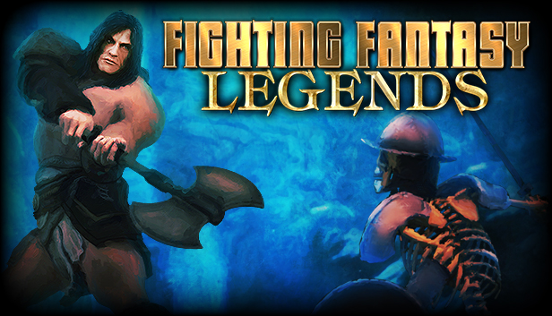
Developer: Nomad Games
Publisher: Nomad Games
Platform: Nintendo Switch
Genre: RPG / Adventure
Release Date: 27 Jul, 2017 (Steam, iOS and Android) - September 23rd 2021 (Nintendo Switch)
Players: 1
An Iconic Adventure Awaits!
Following the success of Deathtrap Dungeon Trilogy, Nomad Games is bringing even more adventures in the world of Fighting Fantasy to Nintendo Switch.
Based on books from renowned authors Steve Jackson and Ian Livingstone (co-founders of Games Workshop), Fighting Fantasy Legends takes three classic game books (City of Thieves, The Warlock of Firetop Mountain and Citadel of Chaos) and transforms them into one single grand adventure across the land of Allansia. With a unique dice based combat and luck system along with thousands of choices to make across all three books, this adaptation offers something for old and new fans alike.
Reimagined as a top-down RPG, players are tasked with exploring a world full of dangerous monsters and making tough choices at every turn. Alongside all the classic choices players can expect from the original books, Fighting Fantasy Legends gives each dungeon, town and encounter a unique deck of cards containing treasures, monsters and other events to encounter. Ensuring that no game is ever the same, players can expect a classic adventure with hours of content to explore and overcome.
Available on the Nintendo eShop from August 27th 2021, Fighting Fantasy Legends joins a range of other titles from Nomad Games now available on the Nintendo Switch, including titles such as Talisman: Digital Edition, Deathtrap Dungeon Trilogy and Mystic Vale.

Social Links
Web: https://www.nomadgames.co.uk/
Twitch: https://www.twitch.tv/nomad_games
YouTube: https://www.youtube.com/c/NomadGamesOfficial
Twitter: https://twitter.com/Nomadgames
Instagram: https://www.instagram.com/nomad_games/
Facebook: https://www.facebook.com/NomadGamesLTD/
More information
If you’d like any more information, please contact Thomas Young via press@nomadgames.co.uk

